# Implementing Module which are not Pre Install: -

**Go to the link :-** [**https://apps.odoo.com/apps?price=Free&series=12.0**](https://apps.odoo.com/apps?price=Free&series=12.0)

You will find many Module freely available which we can for implementation and better learning.

Don’t forget to select version of Odoo which is **12**

When you download the file it will be download in Zip format so extract it and copy that file into

Following steps mentioned;

**1-Go to Files**

**2-Then go to Other Location**

**3- Select Computer**

**4- Search for odoo**

**5- Then enter (CTRL+h)….you will get hidden folder namely (.local) which we are using**

Use **.local** folder and press enter if its asks for Authentication enter password and can processed for the steps mentioned below anyway you have to make it public for using in on server and for that open terminal and follow below step;

Type (**sudo chmod 777 –R /odoo/\***)this will make it local and can be accessible over the server

Inside .local folder go to

**1- share**

**2-Odoo**

**3-addons**

**4-12.0**

**And paste the file which you have Unzip and copy whole folder over here**

After completing the Above step Successfully then open 2 terminals;

In 1st terminal type-

Goto to the directory were odoo is been present

Step 1 - **Cd /**

Step 2 - **Cd odoo**

Step 3 - **Cd odoo-server**

Now follow the below step to stop the server

Step 1-**sudo service odoo-server stop** (to stop the server)

(start,restart,status ..etc are the command which can play vitol role in coming time )

Step 2-Then go to your Browser were your Localhost server of odoo which is running will get stopped after refreshing

Step 3- Then start server again by typing (**./odoo-server**) on the same terminal and server will get started

In 2nd terminal type-

Step 1- **cd /**

Step 2- **Cd odoo**

Step 3- **Cd odoo-server**

Step 4 – **sudo su odoo** (for working in that particular directory which we have performed task in step 1,2,3)

Step 5 - **./odoo-bin –addons-path=”folder path”**

FOLDER PATH is the path were you have copy your Unzip file

Finally Goto to the browser and reload the Odoo localhost page and follow steps;

Step 1 - **Go to Setting**

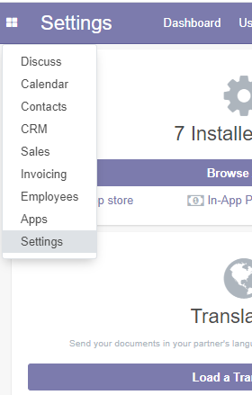

Step 2 – **Then on the same page at right middle you will get Developer Mode and select that and can processed further**

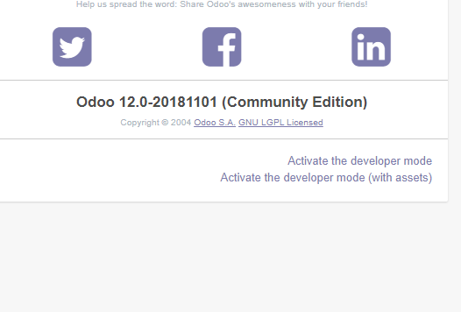

Step 3 – **Look for the Module that you have download and you will find module and Install**

Step 4 – **Then again go to setting and Deactivate the developer mode**

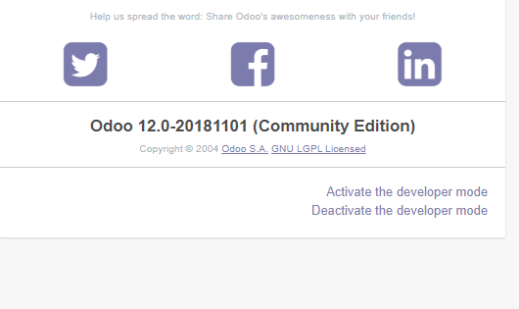

sudo pkill -9 python (to kill the state of python running in background)

# NOTE:

**Have not yet successfully implemented the documented material as fetching issues and yet to get it confirmed with the sir same issues is been observed on Desktop 1, Desktop 2, Desktop 3 and have talked to sir regarding the issues and getting worked on it.**

**Steps and Procedure will remain same and it might have minor changes.**

**Unfortunately, Documented Material is the same in the way sir has taught but then to fetching issue.**